**List of 1st Grade supplies 2023-2024**

🞏 1 – Crayola crayons (24ct.) – Crayola Brand 🞏 1 – Fiskars scissors

🞏 1 – Pack of Expo markers 🞏 1 – Box Quart size Ziploc bags

🞏 1 – Box Gallon size Ziploc bags 🞏 1 – Disinfecting wipes (35ct.)

🞏 4 – Elmer’s school glue sticks 🞏 2 – Large white erasers

🞏 12- #2 pencils (Ticonderoga Dixon or U.S.A Gold)  🞏 2 – Boxes of Kleenex

🞏 4 – Spiral Grade 1 Tablets

**🞏** 2 – Composition Books (Wide Rule)- any color

🞏 2 – Composition Journals – any color

**Lista de útiles para 2023-2024**

🞏 1 – Crayones Crayola (24ct.) – Marca Crayola 🞏 1 – Tijeras Fiskars

🞏 1 – Paquete de marcadores Expo 🞏 1 – Caja Ziploc _cuarto de galón

🞏 1 – Caja Ziploc de galón 🞏 1 – Toallitas desinfectantes (35ct.)

🞏 4 – Pegamentos de barra Elmer 🞏 2 – Borradores grandes color blanco

🞏 12 – Lápices #2 (Ticonderoga Dixon or U.S.A Gold) 🞏 2 – Cajas de Kleenex

🞏 4 – Libretas para primer grado _ con alambre en espiral

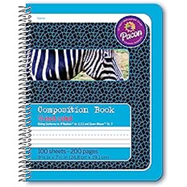

🞏 2 – Libros de composición (Wide Rule) _ renglón ancho, cualquier color

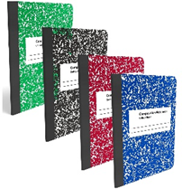

🞏 2 – Composition Journal – cualquier color

